2012
Prof. Gervais

Victoria Skarbinski

[Netflix]
A case analysis on the movie rental company Netflix.

The major portion of revenue that Netflix derived came from its unlimited streaming plans that included either one, two or three DVD’s out at a time from the mailing system.
Netflix began as a DVD rental provider that allowed customers to use the internet to select the DVD’s they wanted to rent.
Netflix’s strategy so far has included offering various plans that incorporate unlimited streaming to a viewing device from the internet and a mail order system that sends physical DVD’s to the customer for an unlimited amount of time without any additional fees (so long as they still have a subscription with the company).
With consumers moving toward the digital era, which Netflix has embraced, Netflix has to focus on continuing to be an innovative leader in the movie rental industry.
- Identify the key elements of Netflix’s strategy. What competitive advantages is Netflix trying to achieve?
Netflix strategy consists of at least six major elements, but its key elements consist of:
- Providing subscribers with a comprehensive selection of DVD titles.
- Giving subscribers a choice of watching streaming content or receiving quickly delivered DVD’s by mail.
- Offering nine different variations of their service with subscription costs ranging from $4.99 to $47.99 with a free one month trial on any service.
One of the most basic features that any movie rental company needs to have is a comprehensive selection of movie titles. Netflix not only has a wide selection of movies that customers may rent from, but its warehouse and electronic ordering system allows it to offer any movie that it owns to 98% of subscribers in one business day. The warehouses that hold all of the movies are strategically placed in various locations to enhance delivery time. The movies then are shipped out after subscribers go online and add titles to their wanted list. The movies are then shipped to them on a ‘receive, view, return and repeat’ basis. Whereas with the competitors, if one specific store (or vending machine) does not have the title the member is looking for, it may take a few days to get the movie in through store to store exchange. Sometimes, the member may have to go to various stores in the chain to find the video they want. In both cases with competitors, this is seen as an inconvenience.
By offering both video [streaming] on demand or VOD services through the use of an internet compatible device, and one day delivery of physical DVD’s Netflix, may be portrayed as the best contender in the movie rental industry. The availability of VOD services attracts the younger tech savvy target markets of Generation Y and the Millennial’s, while the mail order DVD’s attract the older Baby Boomer and Generation X target markets. This not only gives subscribers more options, but satisfies everyone equally, giving Netflix the competitive advantage based on its perceived value and market coverage as a video provider.
The various subscription categories and prices attract customers of all different economic backgrounds. By offering unlimited mail delivery movies starting at $8.99 a month that subscribers could keep for an unlimited amount of time and never have a late fee, Netflix ‘out-did’ most of their competitors. This is so, based on the fact that competitors charged per-DVD rates, limited the amount of time members could have a DVD in their possession and penalized members for bringing the movie back past its, usually one week or less, due date. Netflix also has the competitive advantage because the company pays postage on all DVD’s that are shipped to and from a subscribers home. Then by including unlimited streaming, Netflix provides even more incentive for subscribers to enroll in a plan because they have the ability to watch over 14,000 movies and TV shows while they wait for their next DVD to arrive in the mail. This offers a competitive advantage because subscribers do not have to pay any additional fees for the streaming.
The idea of a free one month trial is something that attracts many prospective subscribers to the Netflix approach. Whenever a subscriber signs up for Netflix, the company automatically enrolls them to have their first month free as a type of ‘try before you buy’ incentive. If the subscriber does not like the service they have signed up for, all they need to do is cancel before their first month is up and Netflix cancels their subscription. This provides the company with an advantage over their competitors because it alleviates any skepticism of how the process works therefore building the necessary trust from subscriber to company.
- Analyze the evolution of the US market between 2006 and 2009 and the Netflix subscriber data (exh. 1&2). Identify 5 to 6 key success factors (KSF) in this Industry.
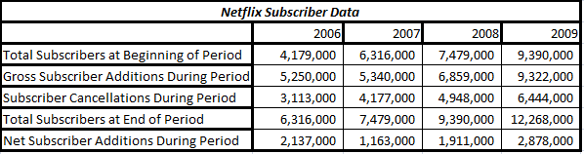
Netflix has done a great job at attracting potential customers. As visible above, Netflix has increased their subscriber total by at least 18.4%, as seen in 2007, annually. Even during the economic downturn, Netflix has continued to add over one million subscribers annually while other video rental companies in the industry were struggling to keep their members.
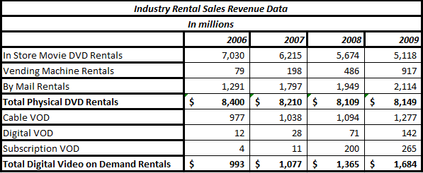
As viewable in the spreadsheet above, the “By Mail” and “VOD” sectors of the rental sales industry are growing annually by 7.8% - 39.2% and 8.5% - 26.7% respectively. The “In Store” sector has progressively decreased in annual revenue. A notable point to touch upon is the increase in “Vending Machine Rentals” over the years. Customers are making use of vending machines due to their ease of access, low prices, and availability along with their “return to any machine, anywhere” feature.
Netflix increasing revenues can be attributed to, but not limited to, these Key Success Factors:
- Quality/ Product Performance: Netflix’s extensive inventory of DVD’s that gets periodically checked for malfunctioning product.
- Dealer Network/ Distribution Capability: The increasing number of ties with video production companies in order to gain access to videos faster while also expanding their current library.
- Technological Skills: Netflix’s convenient and easy to use software that helps subscribers find movies that they have not yet watched but also may match up with their personal taste.
- New Product Innovation Capabilities: Their increasing VOD library that is available twenty-four hours a day, seven days a week through the use of any internet compatible device (ie. Gaming system, computer, or internet capable TV).
- Relative Cost Position: Netflix’s inexpensive monthly subscription fee’s that include instant video streaming and mail delivery of physical DVD’s that are competitively comparable to their rival firms.
- Reputation/ Image: Netflix is known for their fast delivery of mail-order DVD’s, in fact it decreased its delivery time to one day for 98% of its subscribers.

- Conduct a five-forces analysis of the movie rental marketplace, and define how strong each competitive force is.
Rivalry Among Competing Sellers: Medium to High. Technology, features, availability and price are the key factors from which rivalry is focused on in the movie rental industry.
Competitive Pressure from Buyer Bargaining Power: Low to Medium. Buyers have adapted to the use of DVD’s and the internet to view their movies. In many cases, ignoring pirating, the viewer will have to purchase a subscription or pay to view the movie, and at this point the company that is gaining the most headway in the industry while offering low prices is Netflix.
Competitive Pressure from Supplier Bargaining Power: High. Video producers and various content providers have the ability to pull their shows and movies from Netflix if their contracts run out or if they feel they no longer wish to be associated with the company.
Competitive Pressure from Substitute Products: Low. Substitutes such as VHS are no longer widely popular in the video rental market. Blue-Rays are up and coming but their market is limited due to buyer’s disapproval of the cost of the blue-ray player. For those who have the Blue-Ray player, a DVD can also be played on the system which makes the need to change to Blue-Ray Discs minimal therefore lowering the pressure of substitutes. Also, many other VOD companies fees for streaming are higher than Netflix and their server capacity for non-choppy streaming is not as high.
Potential of New Entrants: Low to Medium. Entry into the video rental market is difficult due to favoritism of consumers of their current methods and the current outlook of consumers that demands instant availability and gratification. Entry into the VOD market is a bit higher (medium) due to many up and coming companies creating streaming capabilities and the current availability to buy STARZ and HBO on any cable or satellite provider’s package. But it is also less likely due to the high entry costs and barriers already put up by the current leaders of the market.
- What forces are driving changes in the Movie rental Industry? Are these driving forces likely to be favorable or unfavorable in terms of their effects on competitive intensity and future industry profitability? Why?
The general public’s view of how everything needs to be instant to be a success is probably the greatest force driving the movie rental industry. As seen in the Rental Industry Revenue Sales Data chart from above (pg. 3), the physical movie rental industry is in decline, while the instant streaming and VOD industry is up and coming.
This driving force is likely to be unfavorable in the long term because Netflix will have more rivals competing for the same suppliers to give them streaming rights. This may also hinder Netflix ability to get their viewers streaming availability at a sooner date than other companies.
But from the industry’s point of view, this may be favorable because it will turn the rental industry from something that looks less like a monopoly or oligopoly into a more competitive market position resembling perfect competition. This could happen because streaming will allow more companies to start up without having to purchase individual DVD’s. Instead the start-ups would have to purchase suppliers contracts, and server space.
- Develop a strategic group map of the movie rental industry (Netflix, Blockbuster Redbox, and VOP providers as a group). How attractively is Netflix Positioned on the Map? Explain.
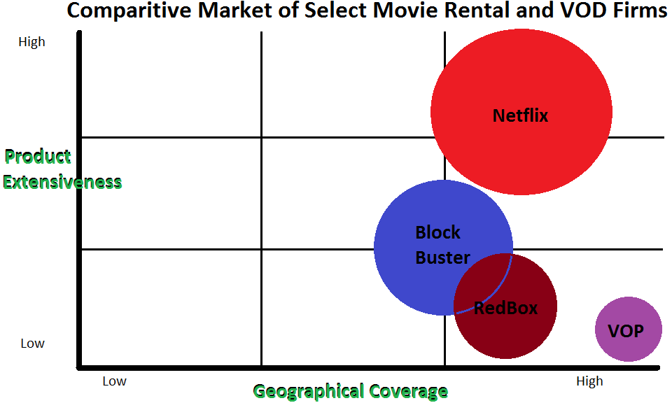
Netflix is in a great place on the strategic group map. It has the largest amount of revenue; it has the highest product extensiveness, allowing subscribers to view both Hollywood and Sundance-type films along with TV shows, and has the second largest geographical coverage. VOP has a higher geographical coverage than Netflix because they are available with any television provider whether or not the viewer has internet connectivity.
- What is your appraisal of Netflix financial performance based on the data in case Exhibits 2, 3, and 4? What positives and challenges do you see in Netflix/s financial performance?
Reference Exhibit 1.
Netflix revenue increases over the four year time span, including during the recession. The ability for the company to not only hold on to current subscribers during a recession but also add on over a million new subscribers each year shows the strength of it.
From 2006 to 2007 the company’s revenue grew by 20.93%, this is a drastic increase for any company, especially in the movie rental industry. While other movie rental companies were losing members Netflix was increasing its revenue and subscribers. In 2007 to 2008, during the worst part of the recession, the company had an increase of 13.22% in its revenues and during the scare of there being a double dip recession from 2008-2009 the company’s revenue soared up another 22.39% finally bringing the revenue to over one and a half billion dollars.
The increases in Cost of Goods Sold throughout the years are not necessarily to be portrayed as a negative financial attribute to the company. With more and more subscribers, a larger quantity of DVD’s and VOD need to be purchased to keep up with the Netflix promise of having a movie delivered in one business day. Even though COGS in 2009 took 64.62% of the company’s revenues, the company was still able to keep 6.94% of its revenues as net income.
Something that is a bit concerning is the increase of marketing expenses from 2008-2009 after it had been on a steady decline from 2006-2008. The $38 Million (making up 14.23% of its revenue for that year) increase may be due to the company having a annual subscriber cancellation for that year of over 34%, (6,444,000 subscribers cancelled of the total 18,712,000 that the company had during 2009).
Another notable financial aspect is the steady decrease in equity since 2007. The company began buying back it stocks in large sums annually with the company’s net income. This buyback may be seen as a good thing or as a bad thing. Some would view this as a company saying that they have more revenue than they need, but others would think this is a strategic idea to make their stock look more valuable and not dilute the value during the probable reselling of it at a later date.
Netflix’s return on assets has been steadily over the four year time span of 2006 to 2009. With its greatest increase of 17.05% in 2009 (up 3.62% from the 2008) this is a great predictor of the future and how the company will be increasing its revenue and the return on their investments.
- Conduct a SWOT analysis of Netflix. How attractive is Netflix’s overall situation?
Strengths | Weaknesses
- Netflix is a well known household name.  - Uses marketing to become memorable.  - Attractive Pricing.  - Strong ties with suppliers.  - Wide geographic coverage.  - Offers a wide breadth of movies and TV shows.  - Strong internal technological capabilities. | - High replacement costs from damaged DVD’s  - Delivery time  - Not as attractive to customers that rarely rent movies  - Not all movies are on the video streaming program.
Opportunities | Threats
- Offering the movies that a customer might rent multiple times on their specific video streaming channel.  - Creating specific channels with combinations of various TV episodes the subscriber watches and movies that are recommended to the subscriber.  - Offering incentives to subscribers for referring a new subscriber that stays for at least one year.  - Open up some Netflix vending machines. | - Blockbuster and Hulu are increasing their streaming members.  - Some VOD channels are becoming less expensive or are offered free for long amounts of time.  - Cutting out the Mail Order system could potentially make the company lose a lot of subscribers.  - Suppliers now have more options to sell streaming rights to; meaning Netflix may lose some of its current contracts.

Netflix currently is in a very good predicament, but it still needs improvement. Currently Netflix has the most variety and availability, but that could change with time so the company needs to continue to search for other mediums through which customers can get DVD’s. Maybe Netflix will look into vending machines.
- Conduct an un-weighted competitive strength assessment comparing Netflix, Blockbuster, and the VOD providers as a group. How does Netflix’s competitive strength compare against that of Blockbuster and rival VOD providers?
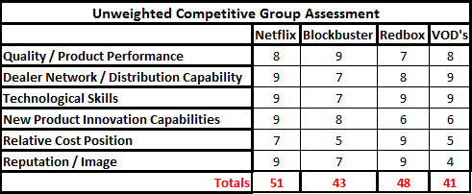
Although Blockbuster’s business strategy more closely aligns with Netflix, Netflix is more closely comparable through the findings of the above un-weighted competitive group assessment with Redbox. Netflix proves to hold the highest ratings in these categories but Redbox follows close behind due to their inexpensiveness and reliability. Netflix received higher ratings in new product innovation capabilities because it already has subscribers and the support system to create a new product that could be tested within their system. Netflix also received higher ratings in quality / product performance because every year the company checks its warehouses for bad DVD’s and discards them, whereas with Redbox, the only maintenance checks that are done happen when a customer informs them of a problem. Netflix received a higher rating in dealer network/ distribution capabilities because they have direct ties with many production companies and they send the movies directly to the subscribers house, Redbox has vending machines everywhere but it can be an inconvenience to movie watchers when the movie they would like to view is not within the vending machine.
In a comparison of strictly Netflix, Blockbuster and other VOD providers, Netflix has the highest ratings. Blockbuster’s image, lack of technological skills and relative cost position cause its ratings to fall eight points below Netflix. Although Blockbuster had been around longer than Netflix, it formed enemy’s with a lot of its previous patrons due to its late fees and its different due dates depending on the newness of the DVD. Other VOD providers also do not have a great reputation due to their high costs and the difficulties that can occur when streaming or ordering a movie selection due to delays.
- Are you satisfied with Netflix’s overall performance? Do you have any concerns? What 2-3 top challenges and priority issues does Netflix management need to address?
In general, Netflix is doing really well as a company. They have products that are on demand and the company distributes DVD’s in a timely fashion to subscribers. Netflix makes the unsubscribing process rather easy so subscribers do not have to worry about getting charged for longer than they wish to have ties with the company. This also comes in handy with the one month free trial; if a subscriber does not like the company and unsubscribe within the first month they no longer receive DVD’s and they can rest easy knowing their credit card will not be charged beyond the day they cancelled their subscription.
Netflix currently holds the most clout in the market based on the evaluation of Netflix, Blockbuster, Redbox and other VOD providers. It has a winning set up with its extensive online catalog that recommends titles to subscribers that the database has matched to their personal preferences. Also, the online program has a waitlist feature so that subscribers can choose a few movies that they would like to view and Netflix will send them a new one every time the subscriber mails back a DVD causing the wait time to be cut drastically. By subscribing for Netflix, a person need only go as far as their mailbox to get a DVD, and does not have to make a trip to the closest vending machine or other distribution center. In many cases subscribers do not have to travel at all, and can stay at home and watch over 14,000 titles from an internet connected device for a price that is included in their original subscription fee. They do not have to pay the costly prices that many other VOD companies charge for unlimited viewing pleasure.
With that said, Netflix does have a few minor problems with its set up:
- The current set up deters many adults ages 50 and up from using the service. The fact that it is all computer based and online intimidates many of its potential customers of the older generations.
- Although its advertisements are funny, Netflix does not advertise that it has more than just movies for subscribers to rent, as much as it should. Many customers that do not watch movies very often miss out on the company’s wide selection of TV shows, workout videos, and children’s entertainment.
- Netflix’s delivery system is still seen as a negative aspect because people are all about instant gratification. People do not plan as much as they did in the past, so if they want a specific movie for a specific day, they feel like they are better off going to a Redbox or a physical video store to rent the movie, instead of waiting for the movie to come by mail.

- What recommendations would you make to Netflix CEO to insure it meets its objectives in the future and to address the top challenges and issues identified in question 9?
Recommendations:
- Netflix should set up an advertising campaign that describes the ease of access. An example commercial would look like the following:
  - It would start with a man sitting on a computer asking his wife what they should rent. Then it should show the recommendations. The wife should view the recommendations and get excited because she always wanted to see the movie that was recommended but had forgotten about it. Then after the man clicks the button to get it ordered it should turn to a comical scene in a warehouse. The Netflix warehouse should have this red alert siren that says ‘the Jones family has just ordered “such and such” movie’. Then a bunch of people should run into action finding the movie. The focus should be on how quickly the movie moves from warehouse to the post office to the mailbox in a mildly comical way. Then it ends with Mr. Jones calling to his wife saying “Honey, the movie we ordered is in!” and she replies “That was fast!” and a quick flash to the workers back at the warehouse out of breath as another red alert siren goes off.

- Netflix should create a documentary of the company and give it to different television stations such as CNN, ABC, and NBC that talks about its successes, but also shows prospective customers just how easy it is and all of the benefits. This would draw in a larger population of the older generation due to the fact that they are the most likely viewers of something like this.

- Netflix should widen its advertising campaign on billboards to include phrases that allude to the company having a huge multitude of stream-able movies. Maybe including a picture of a college student watching a movie on his/her laptop, with a view out the window of his/her apartment of the mailman at his mailbox that says “Watch while you wait”.

- Netflix should put advertisements in newspapers and in magazines that say something about how not only do they have movies but they offer a wide variety of TV shows too. The advertisement should also include the words “Starting at only $8.99 a month with unlimited streaming and your first month free”.

- Creating more ties with production companies is very important for Netflix too. With the up and coming video streaming marketplace, it is very likely that they will have more competition with others looking to create similar ties. So by strengthening them now they may make it more difficult for production companies to pull away from Netflix.

    - Also, this would increase their streaming library which is possibly one of the greatest attractions to subscribers.

- Netflix should create a reward program for its current subscribers. If they refer a friend and the friend stays on for a year, the referring friend gets one month free. This may boost their profits.

- Netflix should open a few vending machines. These vending machines would take back videos that a subscriber had rented and exchange it for a new video. These should be accessible twenty four hours a day and seven days a week. Then when the subscriber sends a DVD back in the mail he or she will receive the next movie on their requested list. The vending machines should have intelligent features that tell the company if the subscriber has viewed a movie from the vending machine that was also on their “to be watched” list.

In sum, Netflix is doing well within their industry market sector, but there are some changes that could be improved upon that would increase their revenues and subscriptions.

Bibliography
Gervais, M. (n.d.). Class Notes and Handouts.
Netflix'x Business Model and Strategy in Renting Movies and TV Episodes, Case 6 (Crafting and Executing Business Strategy 2012).
Thompson, A. A., Peteraf, M. A., Gamble, J. E., & Strickland III, A. J. (2012). Crafting and Executing Strategy: Concepts and Cases. New York, NY: McGraw-Hill Irwin.

Exhibit 1
Netflix
In Millions (except stock price)
 | 2006 | 2007 | 2008 | 2009
Revenue | $996.7 | $1,205.3 | $1,364.7 | $1,670.3
Growth Rate | 20.93% | 13.22% | 22.39%
Net Income | $49.1 | $66.7 | $83.0 | $115.9
Profitablity | 4.93% | 5.53% | 6.08% | 6.94%
Cost of Goods Sold | $627.0 | $786.2 | $910.2 | $1,079.3
Percent of Revenue | 62.91% | 65.23% | 66.70% | 64.62%
General and Administrative | $36.2 | $52.4 | $49.7 | $51.3
Percent of Revenue | 3.63% | 4.35% | 3.64% | 3.07%
Technology and Development | $48.4 | $71.0 | $89.9 | $114.5
Percent of Revenue | 4.86% | 5.89% | 6.59% | 6.86%
Marketing Expenses | $225.5 | $218.2 | $199.7 | $237.7
Percent of Revenue | 22.62% | 18.10% | 14.63% | 14.23%
Total Assets | $608.8 | $679.0 | $617.9 | $679.7
ROA | 8.07% | 9.82% | 13.43% | 17.05%
Long Term Debt and Liabilities | $193.4 | $208.9 | $216.0 | $226.4
Equity | $414.2 | $ 429.8 | $347.2 | $199.1
LT Debt Over Equity | 46.69% | 48.60% | 62.21% | 113.71%
Return on Equity | 11.85% | 15.52% | 23.91% | 58.21%
Stock Price per Share |  |  | $ 29.87 | $ 55.09

